**Integrity statement - “I certify that this submission is my own original work”. Kathleen Paulson.**

**File Names and Description**

add_form.php – input form to add a record to the ‘bookstore’ database. The form is sent to add_form.php after submission. Links are provided for Logout and Main Menu pages. Session control is active on this page (see sessioncontrol.php for details).

add_process.php – processes the add_form.php data sent via post method. Session control is active, and sanitization is done on all input before it is used. The publisher, author and book tables are checked to make sure duplicate entries are not made. Only unique records to the publisher, author and book tables are allowed. Prepared statements with placeholders are used for security. Links are provided for Logout and Main Menu pages.

bookstyles.css - a css file that provides styling for the table used in the list_form.html

delete_form.php – deletes a record from the database. All records from ‘book’ are displayed with a “Delete Record” button under each. The author and publisher tables are first accessed to look up author_id and publisher_id values and provide the details for the form. When the button is clicked, a hidden value of ‘isbn’ is posted to delete_process.php. Session control is active. Links are provided for Logout and Main Menu pages.

delete_process.php – processes the delete_form.php data. If the ‘isbn’ is found in the ‘book’ table, the book is deleted. If not, an error message is shown. Links are provided for Logout and Main Menu pages. Session control is active on this page.

functions.php – contains all php functions used in this project.

index.html – the home page for the project, a bookstore called “Pages Bookstore”. The page provides links to Sign Up, Log In, Log Out, and Main Menu. There is a header and footer, which is the same throughout the website. Finally, there is a brief description about the bookstore and its hours of operation.

list_form.php – lists records from the database, with columns consisting of data from ‘book’, ‘author’, and ‘publisher’. The output is formatted as a table, using bookstyles.css for formatting. Links are provided for Logout and Main Menu pages. Session control is active on this page.

login.php – holds the username, password, hostname and database information.

login.form.html – a form for the user to enter a username and password. On submit, it gets posted to login_process.php. Contains front-end JavaScript validation. Home and Logout links are provided.

login_process.php – this process sanitizes the input data, and then checks the ‘user’ table for a username and password match. The password is salted and hashed first, and compared with the salted and hashed password in the database. The salts stored during the signup process are retrieved from the ‘user’ table and used during the same hash process. If a successful match, session control is established and is active through the main menu and all its components. Links are provided for Login, Logout and Main Menu screens.

logout.php – logs out the user, and destroys the session cookies and the session itself. Links are provided for the Home and Log In screens.

mainmenu.php - Provides a list of links to all menu options: Listing Records, Searching, Adding, Deleting, and Log Out. Links are provided for the Home and Log In screens. Session control is active on this page.

search_form.php – a form for users to enter their search criteria. A drop-down menu has choices for: isbn, title, author (last name), and publisher. The user chooses one of these, and then there is a text box for user to enter criteria. On submit, the fields are posted to search_process.php. Links are provided for Logout and Main Menu pages. Session control is active on this page.

sessioncontrol.php – starts the session. If the session cookie for ‘username’ was not set, the user is redirected to the home page and does not see the current page at all. This prevents users who are not logged in from seeing certain pages.

setupDB.php - Contains php code with MySQL queries to create the ‘bookdepot” database; create the ‘user’, ‘book’, ‘publisher’, and ‘author’ tables; and populate the tables with initial values. The database is ‘bookstore’. The tables are: ‘user’, ‘author’, ‘publisher’, and ‘book’.

signup_form.html – a form for users to register for the site. Front-end JavaScript validation is done on the input fields. If fields are successfully validated, the form is submitted and fields posted to signup_process.php. A link is provided for the Home page.

signup_process.php - processes input data from signup_form.html. Sanitization is performed before the data is used. PHP validation is also done of each field. When the data is ready to input, the password is salted and hashed before insertion. The salts are generated by a random function. The hash algorithm used is sha256. The salts are stored in the ‘user’ database with the other information.

style.css and style2.css – files used to style the website pages.

Images folder – contains all images used in the website.

# Creation of the ‘bookdepot’ database

This database was created using normalization techniques as recommended in the textbook. Indexes were selected based on what I thought the users would need to search on, both now and in the future. The tables are ‘book’ (primary key ‘isbn’), ‘author’ (primary key author_id), ‘publisher’ (primary key publisher_id) and ‘user’ (primary key username). The ‘book’ table contains foreign keys for author_id and publisher_id. The ‘author’ table contains a foreign key for ‘publisher_id’. The tables ‘publisher’ and ‘book’ do not contain any foreign keys.

Screenshot of the output after running ‘setupDB’:

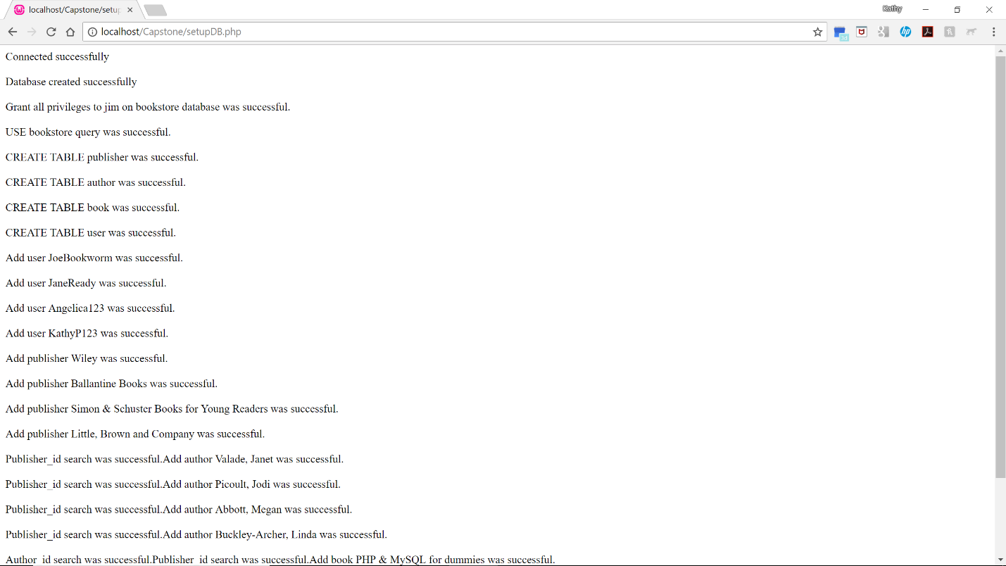

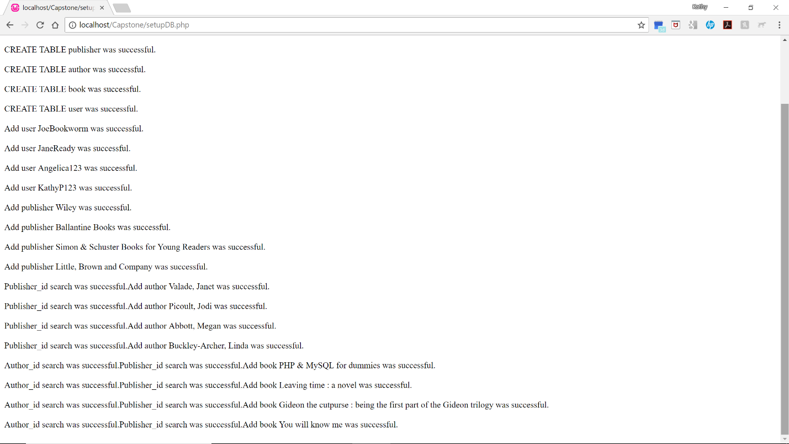

Structure and content of the tables after initial setup:

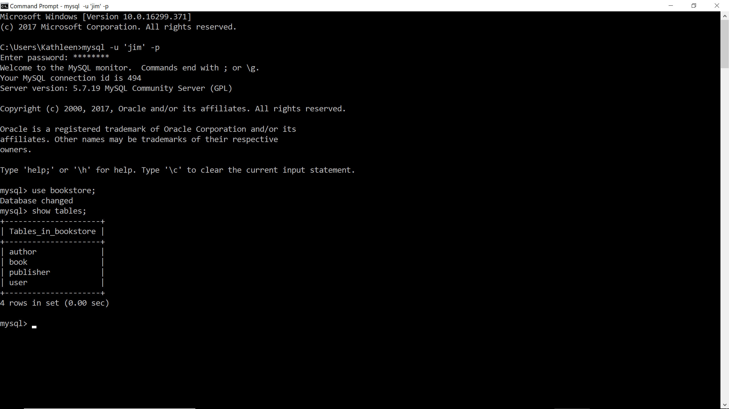

Table detail:

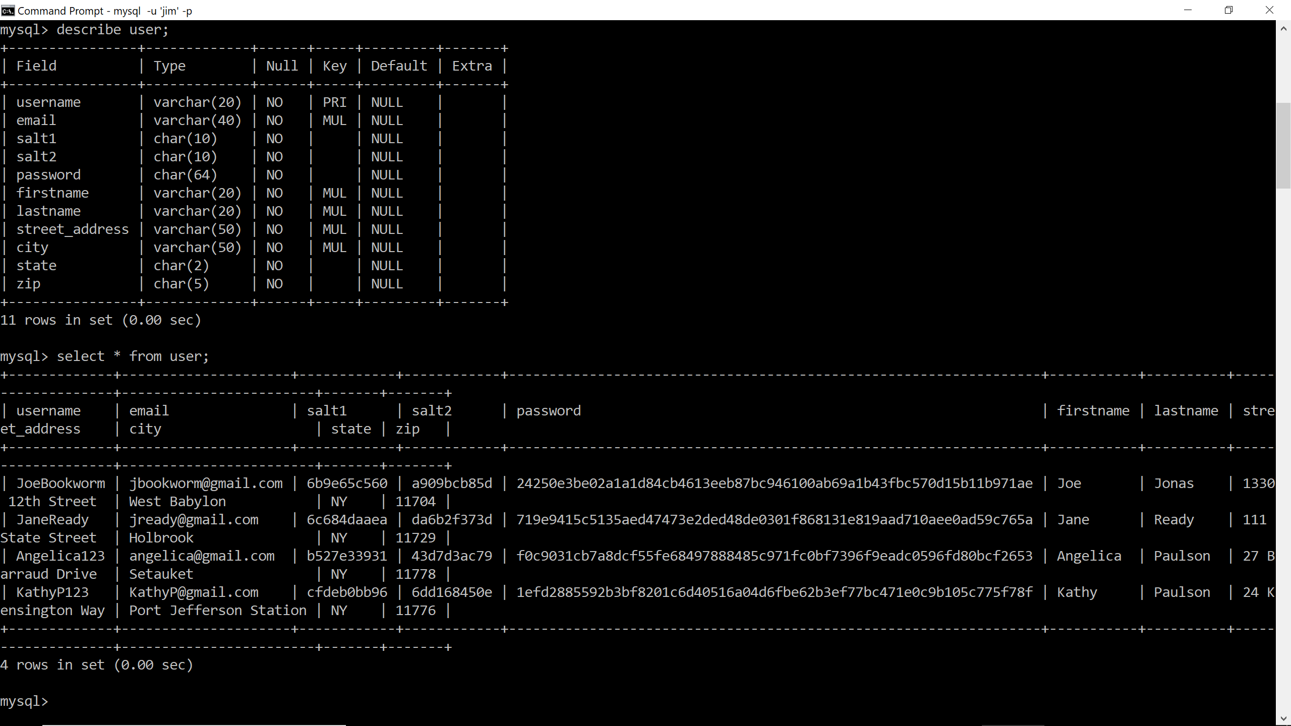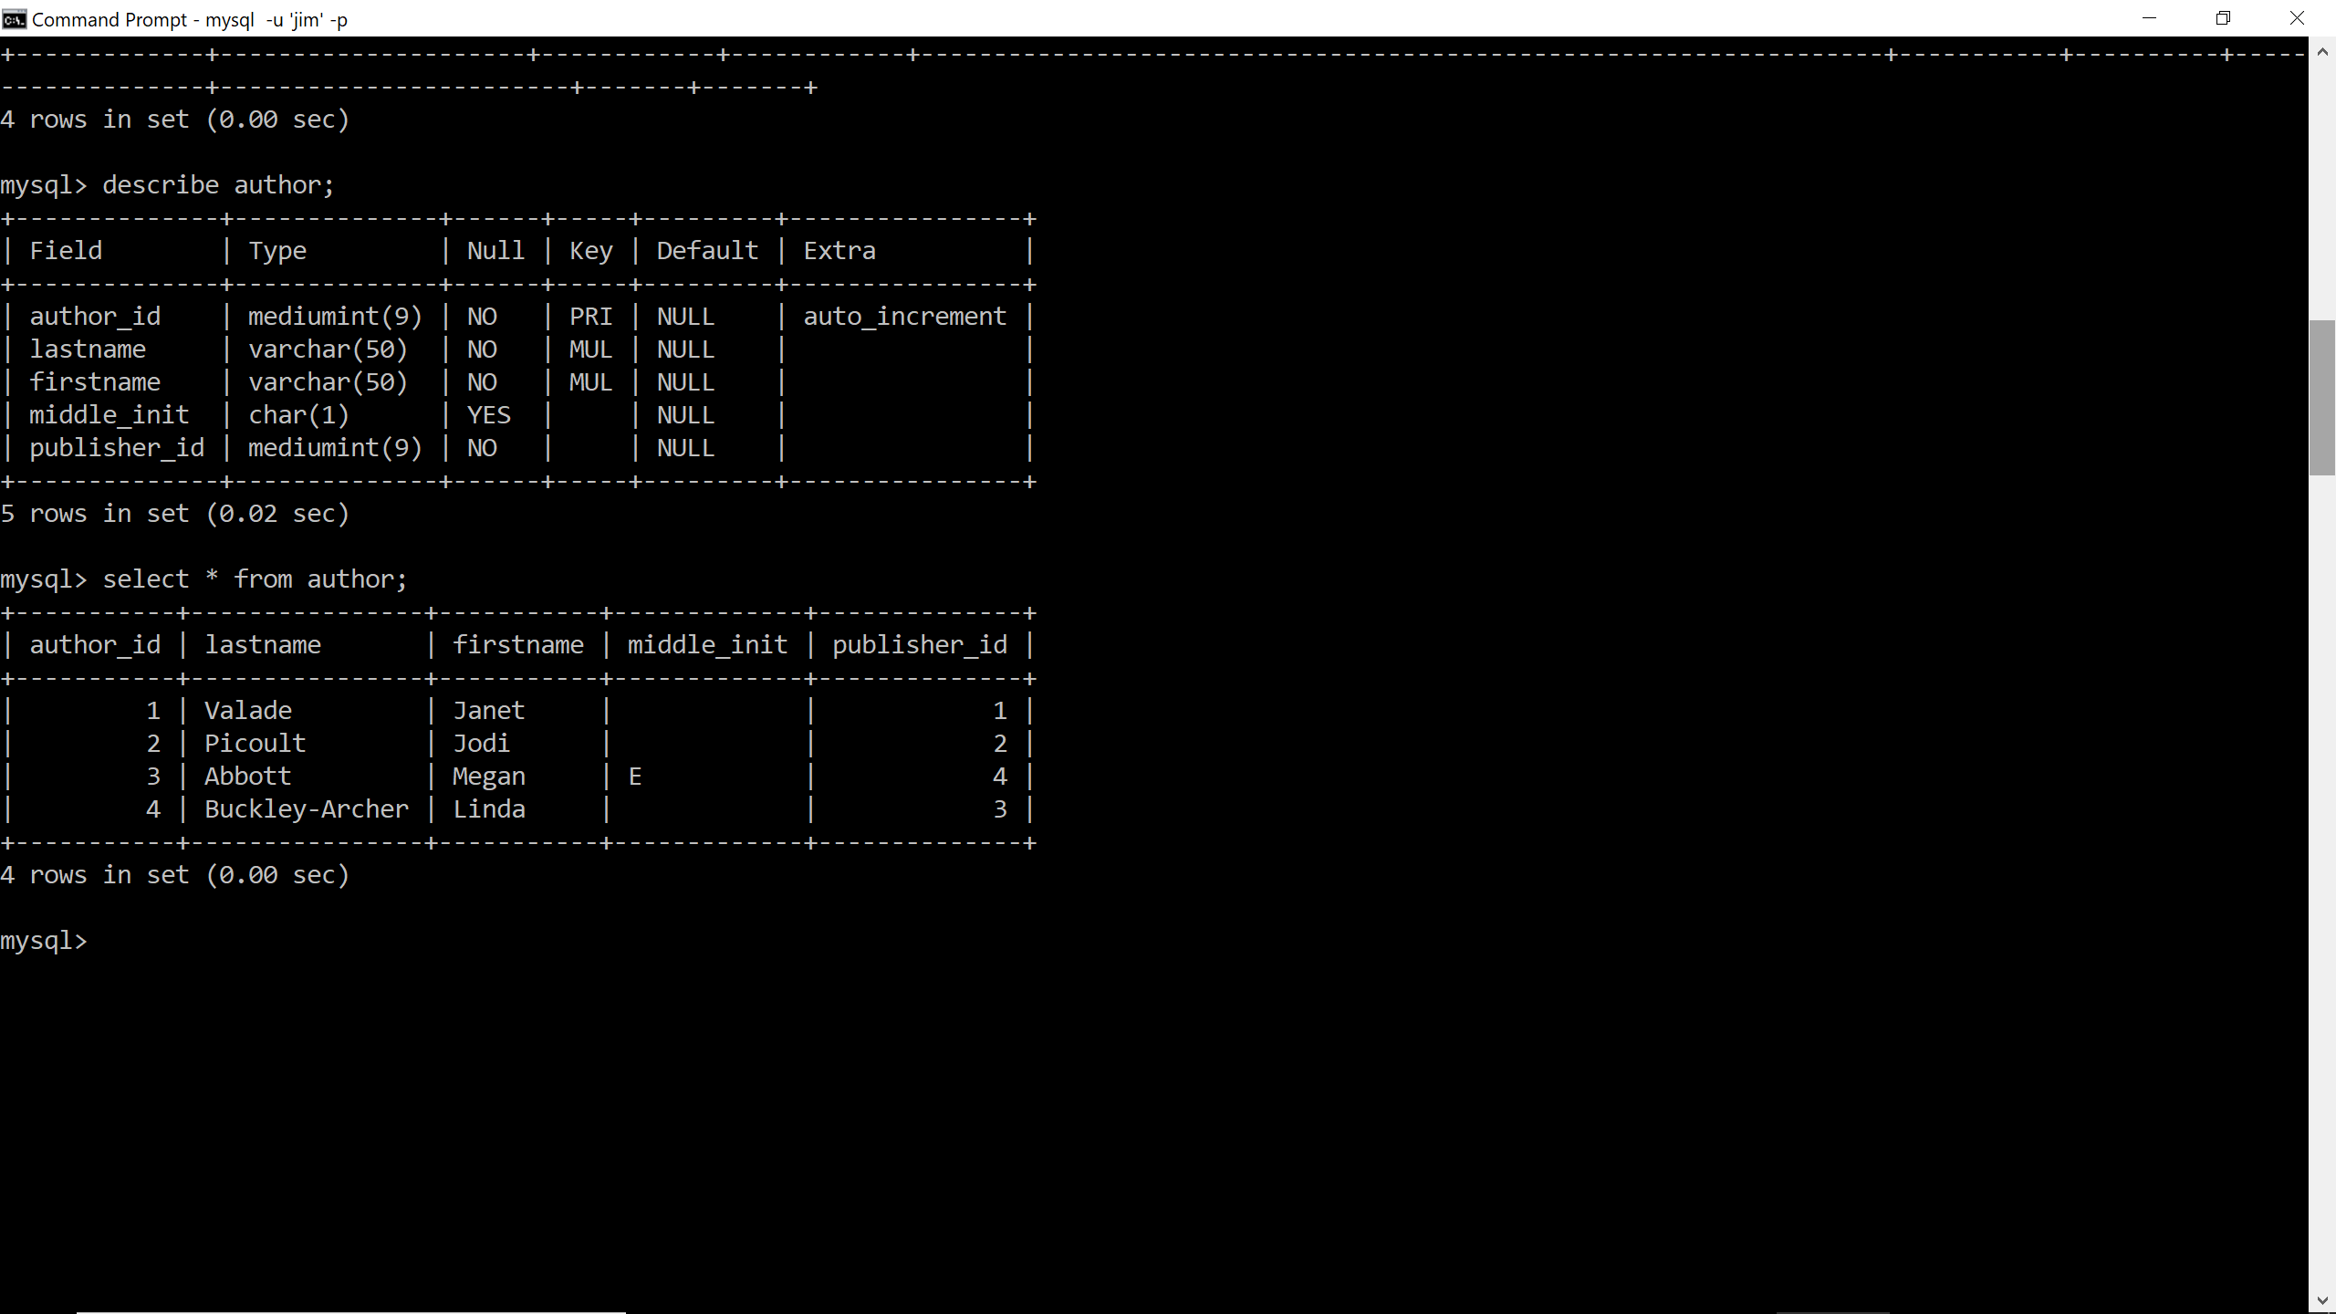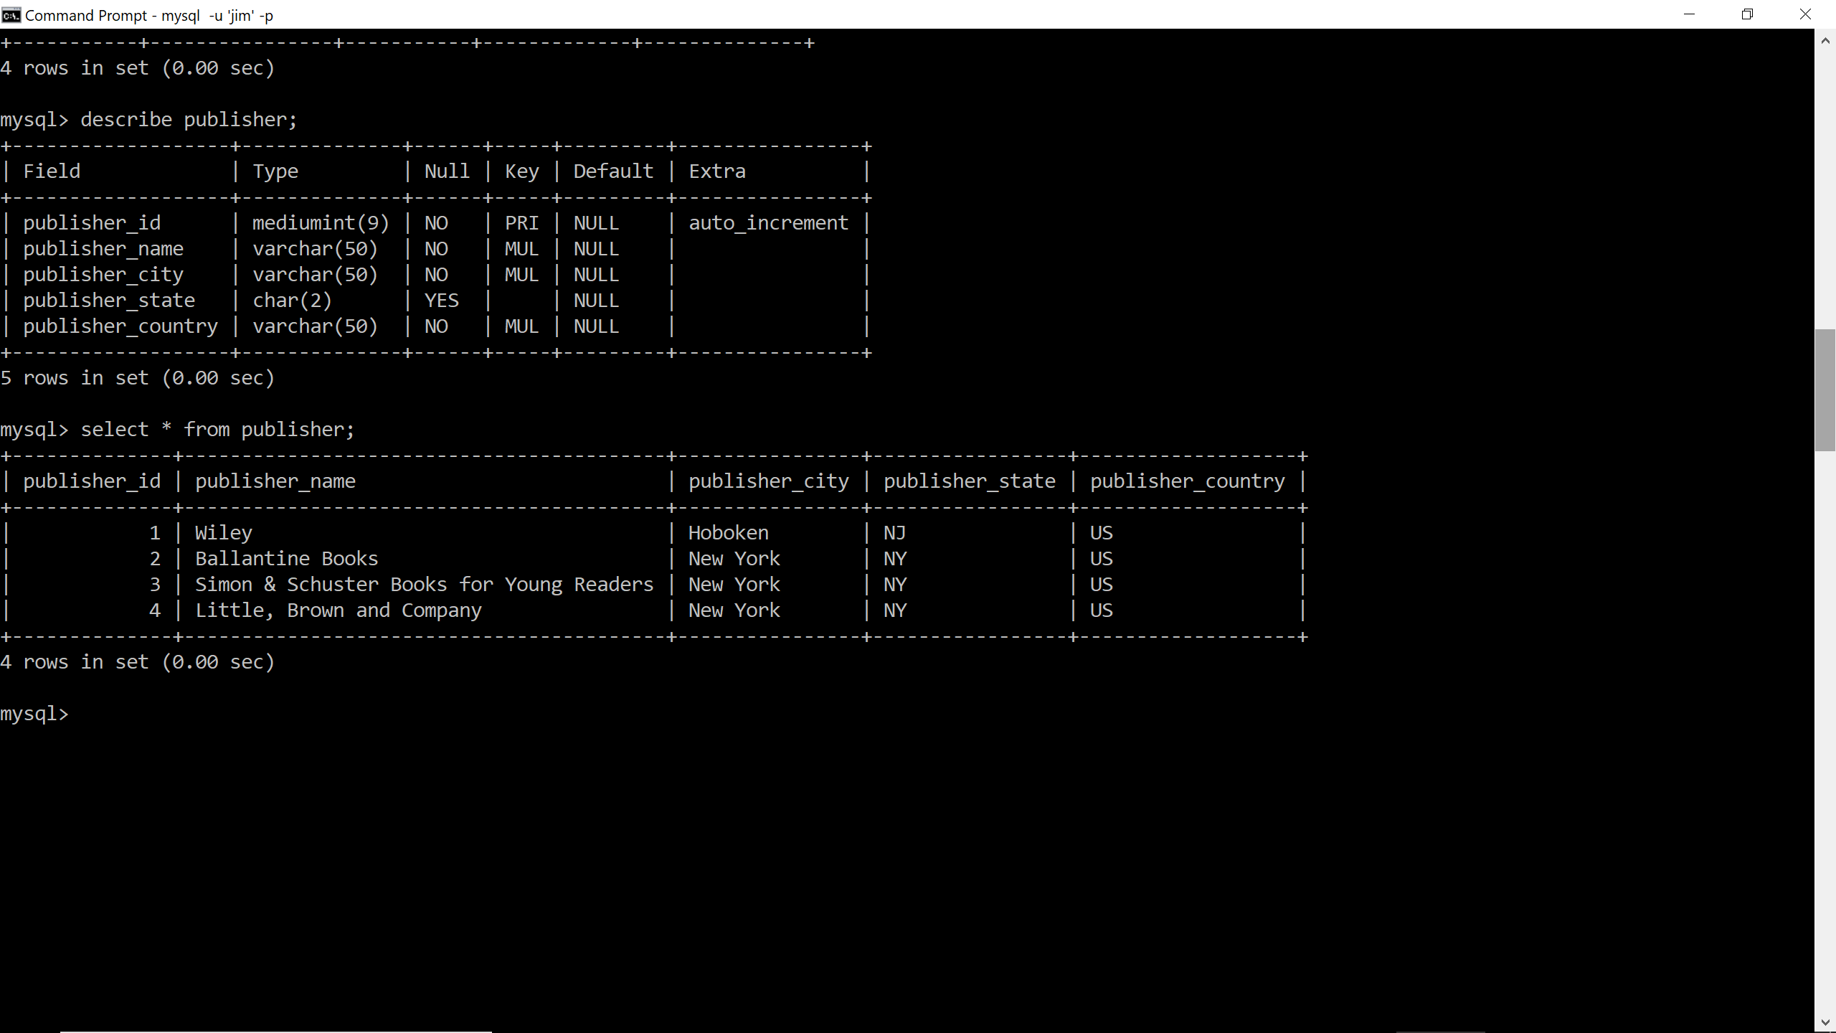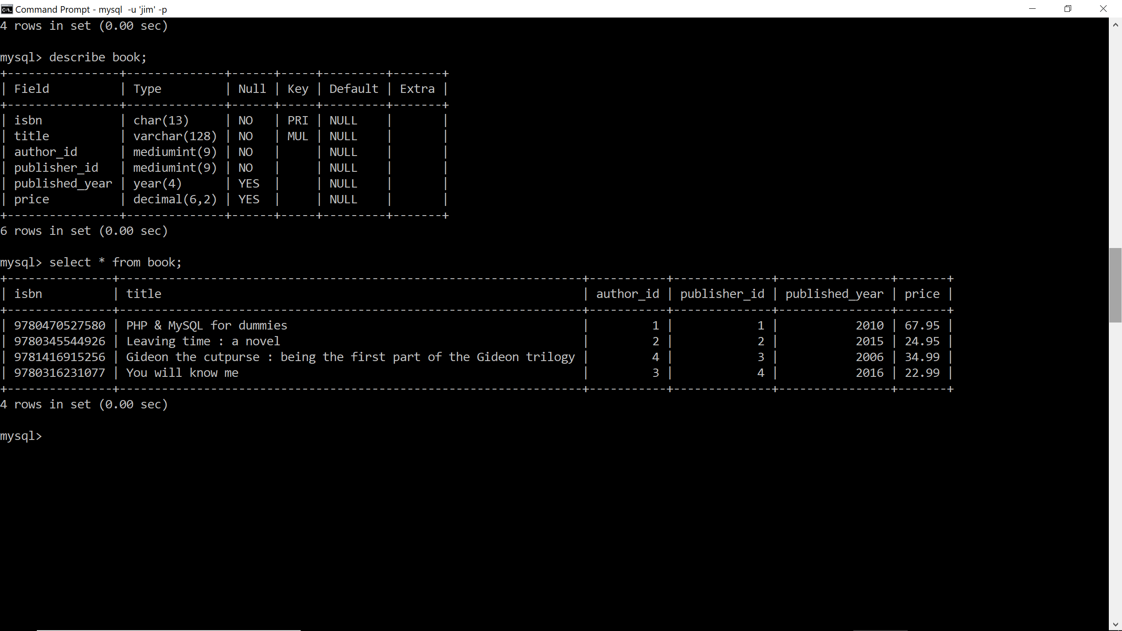

Home page (index.html):



Log In Page (login_form.html):



Log In form with invalid login (username and password do not match):



Log In form after successful login:



Sign Up Form (signup_form.html):

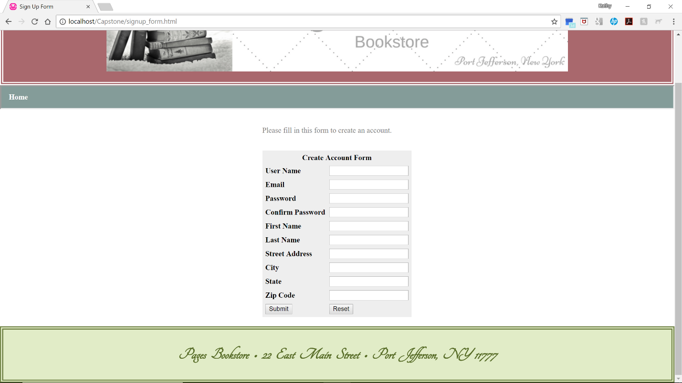

Front-end (JavaScript) validation of Sign Up form:

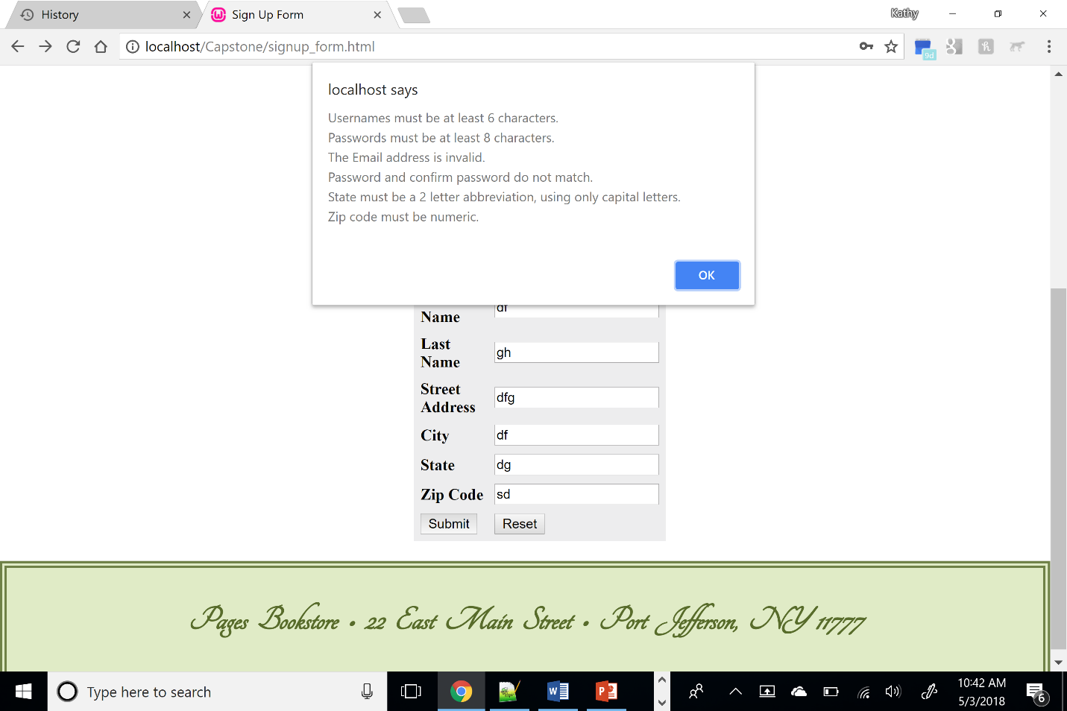

Back-end Error Validation (PHP) of Sign Up form:



Back-end validation of Sign Up (signup_process.php):



Successful Sign Up (signup_process.php):

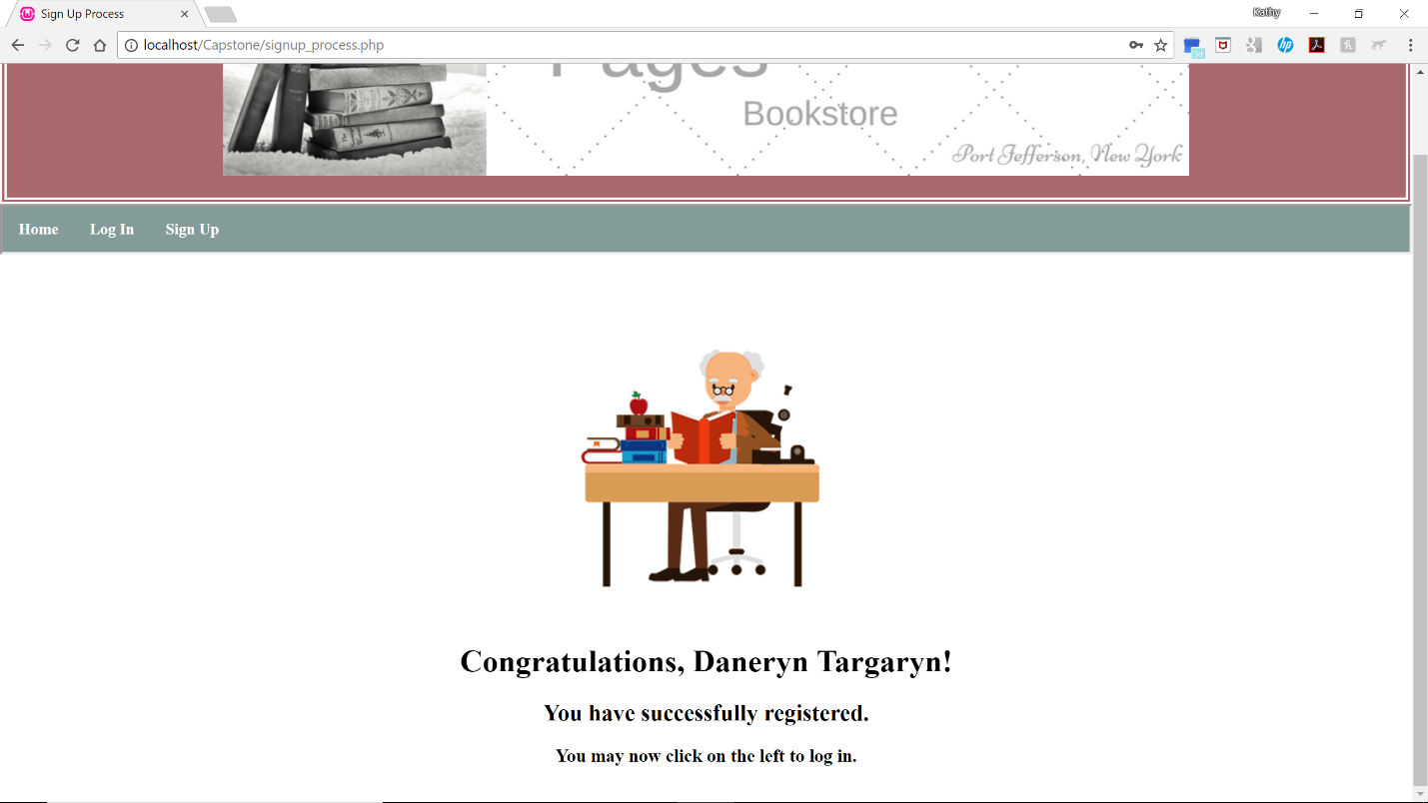

Attempt to access Main Menu when not logged in (mainmenu.php):



Accessing Main Menu after successful login (mainmenu.php):



Listing Records (list_form.php):

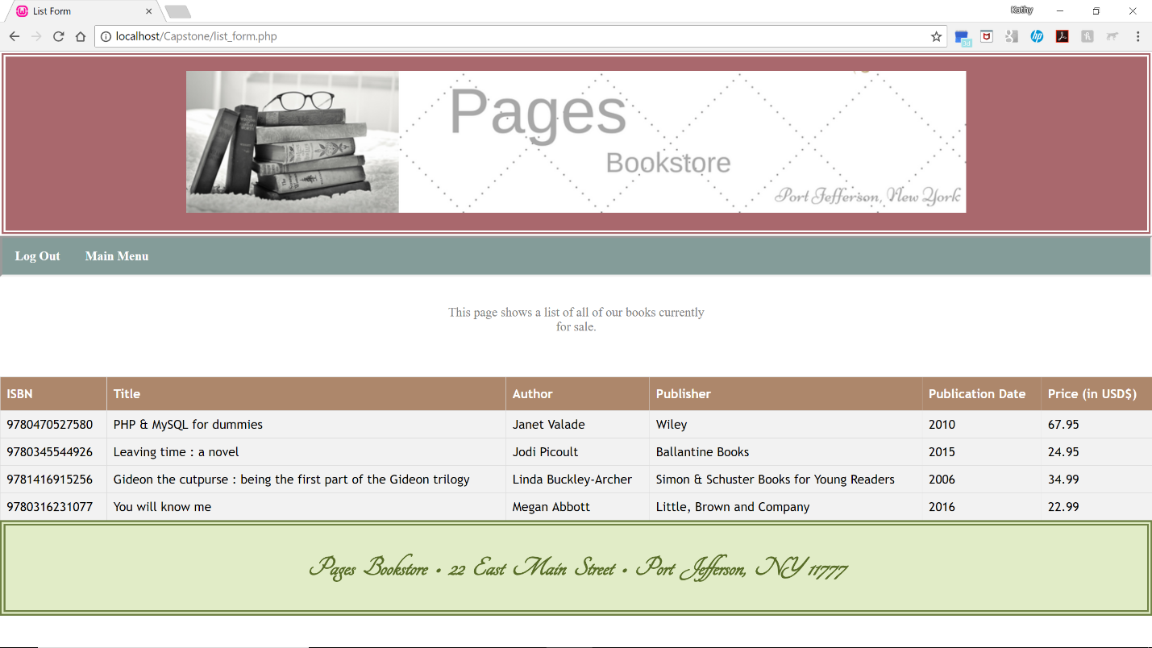

Searching records form (search_form.php):



Search results if not found:



Successful searches for ISBN, title, author, and publisher:

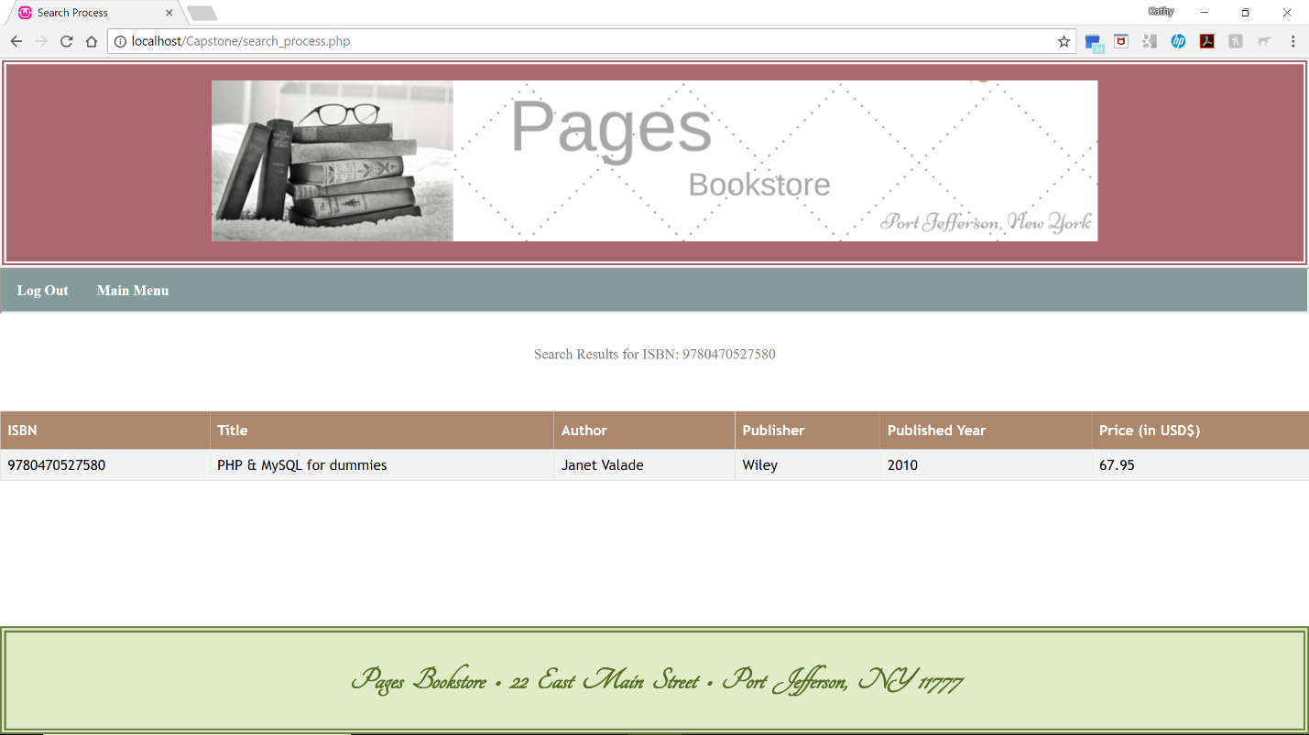

Add form (add_form.html):



If user attempts to add a book, publisher, or author that already exists, an error message is shown such as this:



Successful addition of a new record:



Delete a record (delete_form.php):



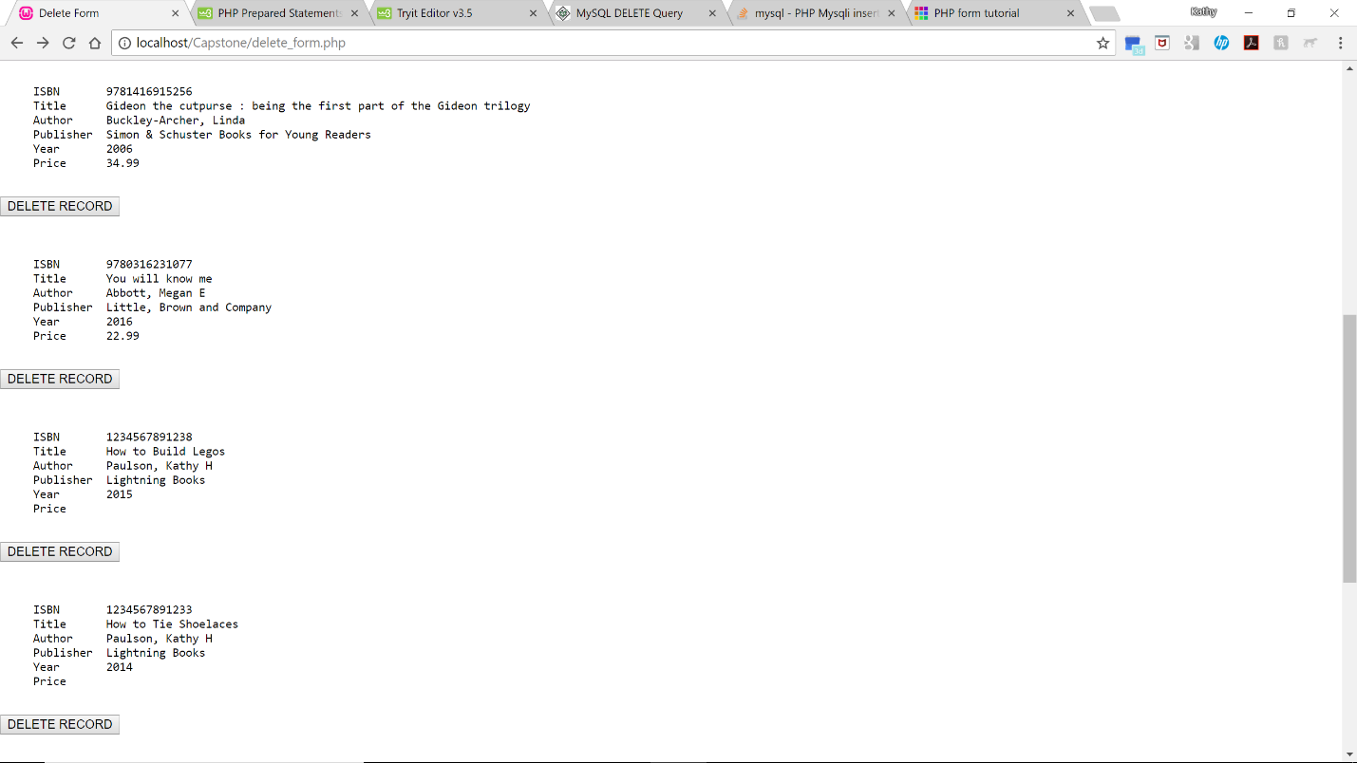

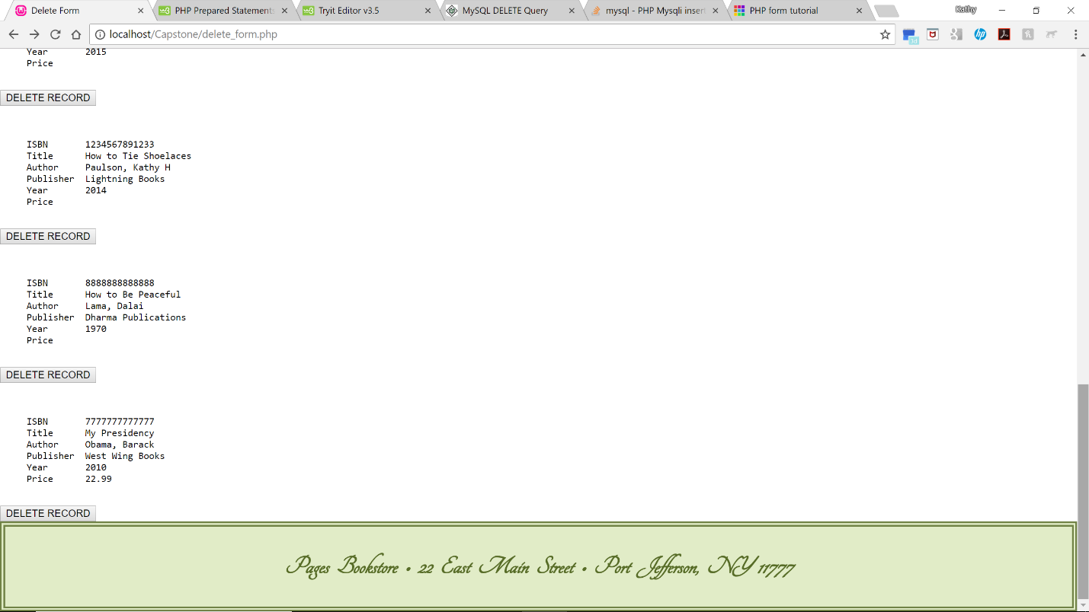

Successful deletion (delete_process.php):



Log Out Form (logout.php):

